**M.E. 530.646 Final Project Report**

**Bo Lei**

**1. Goal**

The goal is to move the UR5 robot through the trajectory I set, so that it is able to draw a picture of a heart with a Chinese word inside if it. Here is the pattern, which is composed of a lot of points and lines connecting the consecutive points:

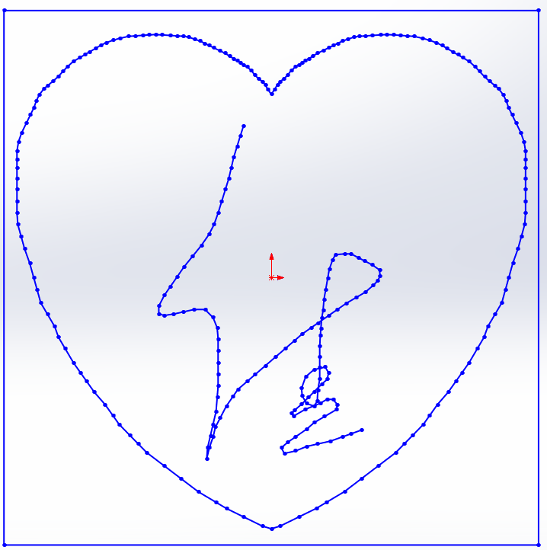

**2. Basic idea**

1. Inverse Kinematics

Move the robot to a very close end-effector position. Move the end-effector through the trajectory step by step.

2. Resolved-Rate Control

Move the robot with a small step each time. The position change in spatial frame is

🡺

In this way, we can move the end-effector through the trajectory by moving the joint angles each time.

**2. Calculations relating to the code**

1. homogenous transformation from body frame to spatial frame

Given the plane normal **n0**, and a point **P0**, compute the transformation between the body frame and the spatial frame:

Body Frame normal:

Ratation Axis: **nr** = -**n0** × **nb**

Rotation Angle:

Then we can get the homogenous transformation from body frame to spatial frame:

gsb =

2. When finishing drawing a pattern, move away from the board with height h:

ph = gsb (pcurrent+

3. Inverse and forward kinematics have been reported in previous lab.

4. Spatial Jacobian:

File：Ad.m, getJacobian.m

is computed in forward kinwmatics

Adg =

**3. Screen shots showing the results**

Inverse Kinematics(Using the 4th inverse kinematics solution):

File: DummyMain_IK.m

p0 = [0;-0.3;0.5];n = [0;1;0];

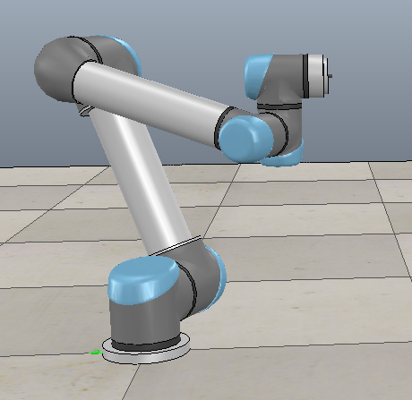 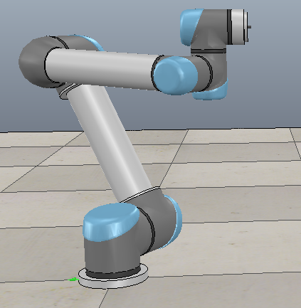

Resolved-Rate Control:

File: DummyMain_jacobian.m

p0 = [0;-0.5;0.5];n = [0;1;1];

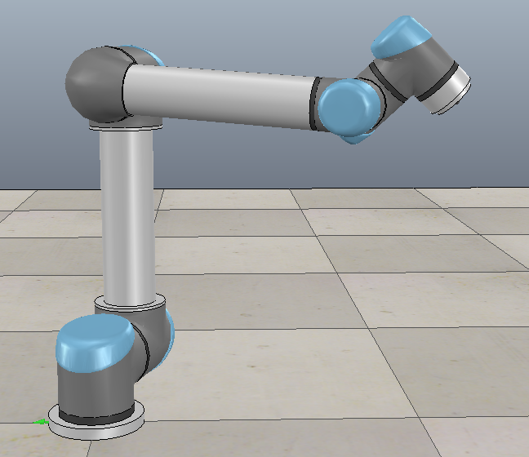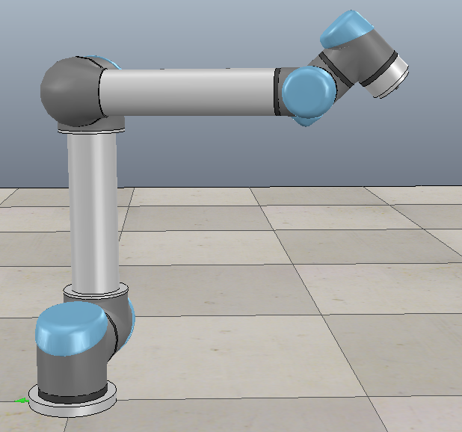

**4. Drawing result**

Inverse Kinematics：

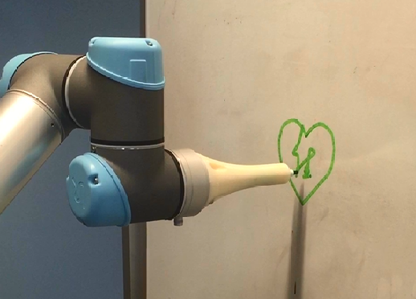

Resolved-Rate Control:

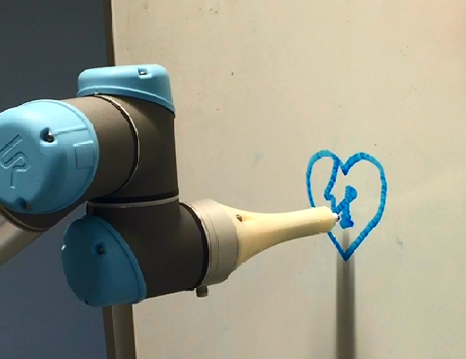

**5. Lab video**

Inverse Kinematics: <https://www.youtube.com/watch?v=9RyKTatm_xo>

Resolved-Rate Control: <https://www.youtube.com/watch?v=xy0HFCJL9QM>